**OUT OF TOWN GUESTS**

Welcome to the Roberts Reunion! We are so glad you are making the trip to come to Roberts Switch and want to make your stay pleasant. The below information may help with your visit.

**VENUE**

The reunion is held in the barn and Heritage House at 9651 Roberts Road, Silver Point, TN.

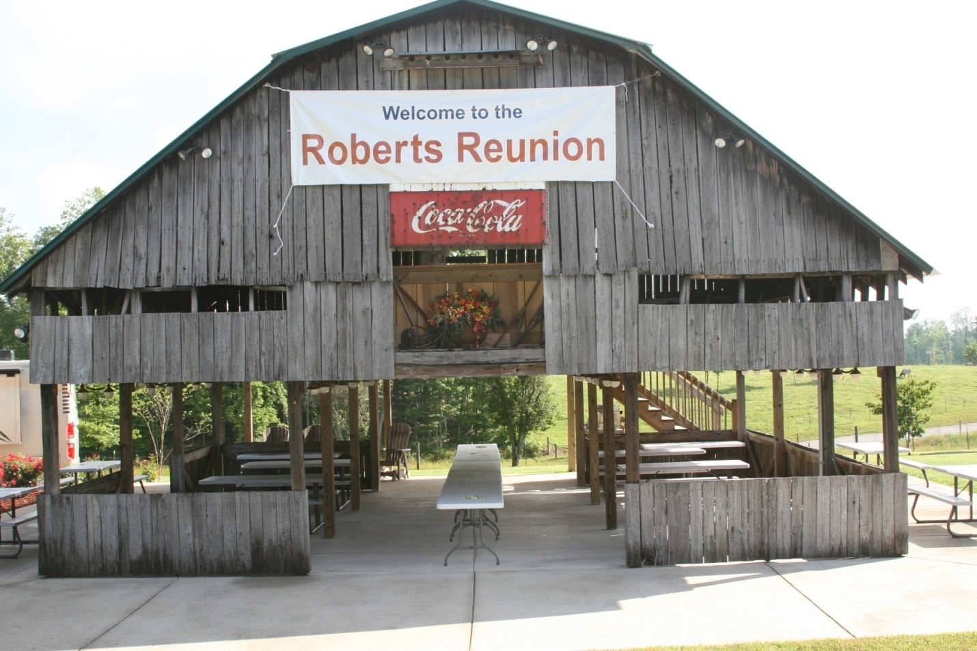

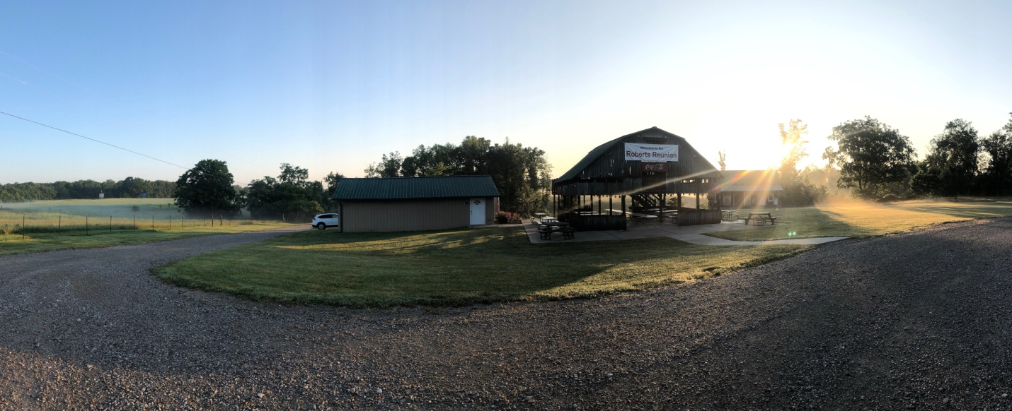

There is gravel parking and a bathroom at the location.

**EATING**

The Saturday event has traditionally been a potluck. Being from out of town, you may not have facilities to make a dish. Cookeville (about 10 miles from our location) has many places that cater, so you may choose to bring something from “town”☺. Here are some ideas that are in our area.



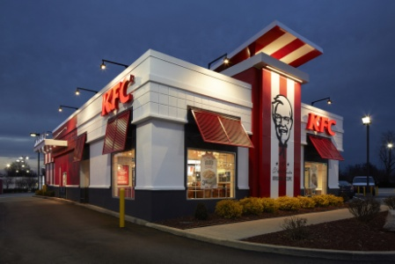







The Rose Garden offers a meat and three; and menu options. It is at 14622 Old Baxter Road.

**LODGING**

Cookeville is the closest city to Roberts Switch that has hotels. It offers numerous hotels that you can stay at. The link to Cookeville TN Visitor Guide is at visitcookevilletn.com/visitor-guide. The guide provides lodging recommendations from hotels to cabins to B&Bs to camping options. The closest RV park for Roberts Switch is the Twin Lakes RV Campground located at 580 Gainesboro Hwy, Baxter, TN. Note: Twin Lakes RV Campground does not have shower facilities.

**FLYING**

Nashville Tennessee’s airport is about one hour away from Roberts Switch.

We want to make your reunion experience meaningful! If there are any questions, please ask!

