**CHILDREN OF JOSEPH ROBERTS**

**CEMETERY TOUR GUIDE**

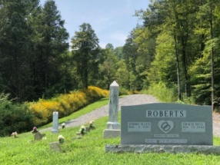 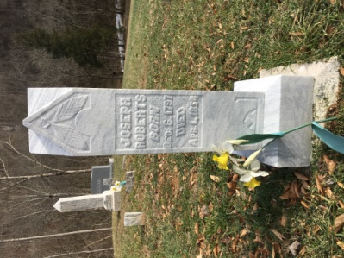 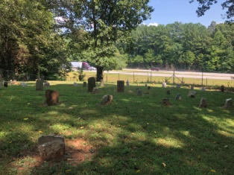 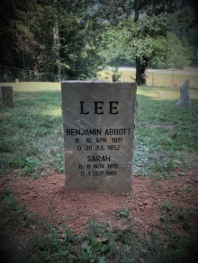 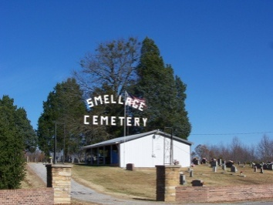 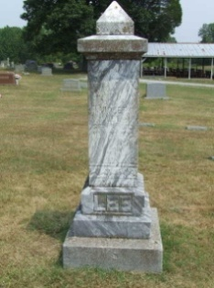 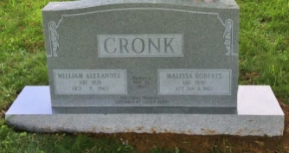 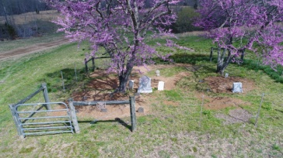 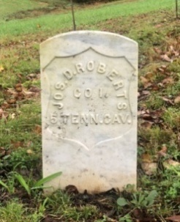

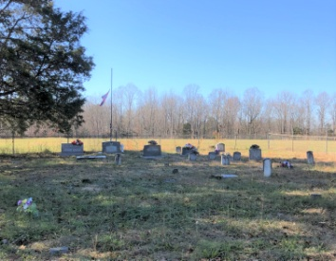 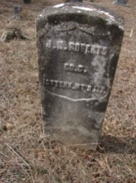

***Gone but not forgotten…***

Welcome to Roberts Switch, Tennessee and our ancestor cemetery tour. This tour takes you to all five cemeteries which the children of Joseph Roberts are buried (except Henry Roberts). The starting point is the Roberts Switch Activity Center (RSAC). There are driving directions from the RSAC to each cemetery, so you can go directly to any portion of the cemetery tour. Or you may do a round robin to all five of the cemeteries with the ending point at the Joseph Roberts Cemetery for its annual Roberts Reunion decoration.

**ROBERTS #2 OR HICKEY CEMETERY**

**FROM RSAC:** Please turn right out of the RSAC and travel on Roberts Road .3 miles to Old Baxter Road. Turn left and travel 1.4 miles on Old Baxter Road. Take a left onto Carr’s Chapel Road. In approximately .6 miles you will reach John Harrison Roberts Cemetery (sometimes referred to as Roberts Cemetery #2) on the right side of the road.

----------------------------------------------------------------------------------------------------

Welcome to the Roberts Cemetery, or sometimes referred to as “Hickey” or Roberts #2 Cemetery. John Harrison Roberts was the son of Joseph Roberts and was born about 1827 in Jackson or White County (now Putnam County), Tennessee and died 19 Jul 1870 on Mine Lick Creek, Tennessee. He married his first wife Mary Ann “Pop” Ramsey on 25 February 1847 in White County, Tennessee and together they had seven children. Pop divorced him in 1869 for adultery. John then married Amanda Martin on 20 February 1870 on Mine Lick Creek, Tennessee. He and Amanda had one son, John Vance Roberts, also known as “Crippled John” due to being crippled in one leg. John Harrison Roberts joined the Union Army and Served with Company C, 1st Regt, Tennessee Mtd Infantry during Civil War. Amanda made pension application based on his Civil War service. He enlisted at Carthage, TN on 21 Oct 1863 for 1 year and was discharged 13 Dec 1864. He held the rank of private during the period of service. His civil war documents described him at age 37 as 6'3", fair complexion, grey eyes and dark hair. John’s death, as told by Walter Roberts: Walter says he had heard the same story all his life. John was shot on Mine Lick Creek just below the Joseph Roberts homestead in the "Logan Herren" bottom. When he was shot, he gave his rifle to "Uncle Allen" (Marion A. his son) and told him "son, remember the man that killed your Daddy." John was taken to his first wife’s house where he died from the gunshot wound. Later (don't know how much later), Uncle Allen got up his winter's wood, left, and was never heard from again. John was called "Capt Roberts" by some. He was likely in the “Mine Lick Gang” during the early part of the war. Perhaps he was a Captain in that group of irregulars. Supposedly he rode with a woman during and/or after the Civil War. After the war, she reportedly gave a man (Swearingill) a horse and a McBride saddle to kill John. Instead, John killed the man, shooting him through a window of his house, while the man sat on his horse. The man, supposedly, was coming to John's house to kill him. Another story has it that they were in a dispute over a cap and ball pistol. According to Walter, the man rode up, shot at John with the bullet hitting the window sill. The man jumped off the horse and ran behind a tree. John shot him as he looked out from behind the tree. The affidavit of F.M. Roberts and J.L. Roberts, referencing Amanda's pension application, state that John "was shot from ambush and died some 17 days afterwards. We were at his death and burial and know the fact therefore that he is dead. His death was in Putnam County, TN about July or August 1870. In addition to John Harrison Roberts being in this cemetery, there are many other Roberts members buried here. Feel free to explore and honor those buried here and pause the recording until you depart to the next cemetery.

**JOSEPH DENTON ROBERTS CEMETERY**

**FROM RSAC:** Please turn right out of the RSAC and travel on Roberts Road .3 miles to Old Baxter Road. Turn left and travel 2.4 miles on Old Baxter Road. You will reach the gate on the left at 14400 Old Baxter Road. The gate will be unlocked. If you want to visit this cemetery at another time, contact Angela Stout. Go through the gate and follow the slightly graveled country road veering to the left. In .4 miles on this country road, you have now reached our next stop, the Joseph Denton Roberts Cemetery.

**FROM ROBERTS #2 CEMETERY:** Please take Carr’s Chapel Road back to Old Baxter road and take a left. Travel 1 mile and you will reach the gate on the left at 14400 Old Baxter Road. The gate will be unlocked. If you want to visit this cemetery at another time, contact Angela Stout. Go through the gate and follow the slightly graveled country road to the left over the hill .4 miles. You have now reached our next stop, the Joseph Denton Roberts Cemetery.

----------------------------------------------------------------------------------------------------

A small family cemetery, Joseph Denton Roberts is buried here. He was born in Jackson or White County (now Putnam County), Tennessee on 8 April 1838 and died 10 April 1901 in Putnam County, Tennessee. He is Joseph Roberts’ youngest son. Joseph had two wives. He married his first wife, Lillie H. McGuffee on or about 1838 and divorced her in 1866. They had two sons, Joseph and William. On 20 Sep 1866, he married Silvia (Silvy) H. Smith in Smith County, Tennessee. Together they had eight children. Uncle Dent served with Union Company I of the 5th Tennessee Calvary. You will notice he has two military tombstones for some unknown reason. This cemetery only has three marked graves, Joseph Denton Roberts, his wife Silvia Roberts and their son, Joseph M. “Joe Blossom” Roberts. There are at least eight unmarked graves. In the spring time, the two redbud trees bloom with pink blossoms and the ground is covered up with white flowers called Jonquils. Take some time and pause the recording until you are back in your car.

**SMELLAGE CEMETERY**

**FROM RSAC:** Please turn right out of the RSAC and travel on Roberts Road .3 miles to Old Baxter Road. Turn right and travel 1.1 miles on Old Baxter Road over the Francis Marion Roberts Memorial Bridge over Interstate 40 until you reach Hopewell Road. Take a left on Hopewell Road and travel .7 miles until you reach Smellage Cemetery on the right side of the road.

**FROM JOSEPH DENTON ROBERTS CEMETERY:** Please go back on the dirt/gravel road to the entrance gate. Exit through the gate and take a right back onto Old Baxter Road and travel 3.6 miles. This will take you past Roberts Road and the Francis Marion Roberts Memorial Bridge over Interstate 40 until you reach Hopewell Road. Take a left on Hopewell Road and travel .7 miles until you reach Smellage Cemetery on the right side of the road.

----------------------------------------------------------------------------------------------------

Smellage cemetery has two of Joseph Roberts daughters buried here, Violet (Roberts) Lee and a memorial marker has been placed here for Malissa (Roberts) Cronk. Both daughters lived hard and inspiring lives.

Violet Roberts is Joseph’s youngest daughter. She was born 6 September 1833 in Jackson or White County (now Putnam County), Tennessee and died of cancer on 22 March 1923 at the home of daughter, Frances Marion (probably named for her Uncle) and Harvey Herd home in Putnam County, Tennessee. Violet was married only once on 1 Sep 1853 to John Wesley Lee in Jackson County, Tennessee. They had four children. Her husband Served with Company D, 8th Regiment, Tennessee Mtd Infantry Volunteers. He enlisted on 1 Feb 1865 at Granville and mustered out on 31 Aug 1865. He died of rheumatism and erysipelas contracted at Nashville while in service. He was treated at Regimental Hospitals and at Carthage, Tennessee. Lois Anderson tells the story that John Wesley was to be buried on the Tucker Ridge but confederate sympathy was against it since he served for the Union. Supposedly they had to slip at night and bury him at the Roberts Cemetery at Hickey. Violet reportedly used every penny from her civil war pension to buy land. She had a reputation for being a tough old bird who was very frugal.

Violet’s sister, Malissa, has a memorial rock in Smellage. We are not sure where her actual grave is. She was born in Jackson or White County (now Putnam County), Tennessee in January 1830 and died between 1 Jan 1907 and 1910. Melissa was married to William Alexander “Bill” Cronk on 19 May 1845 at the home of Snowdon Maddux the justice of the peace. Together they had eight children. Bill was on his way to Nashville to be part of Company C of the 1st Tennessee Mtd Infantry when he was brutally killed by a confederate ambush. Because he was not mustered in, Malissa’s civil war pension application was denied. She was left to care for eight children and also took care of four grandchildren. She never remarried and remained in Tennessee until she died.

Smellage Cemetery has many, many descendants of Joseph Roberts, please take the time to roam the cemetery and think of your heritage.

**LEE CEMETERY**

**FROM RSAC:** Please turn right out of the RSAC and travel on Roberts Road .3 miles to Old Baxter Road. Turn right and travel 1.2 miles on Old Baxter Road over the Francis Marion Roberts Memorial Bridge over Interstate 40 until you reach Lee Cemetery Road on right. You will also see the Boma Church of God on your right. Enter Lee Cemetery Road and travel .1 mile. Go by the church and go over the railroad tracks. Stay to your right and go to the last house on the road. You will enter the gate by the barn and walk to the right side of the barn. You will then see the Richard Lee Cemetery.

**FROM SMELLAGE CEMETERY:** Please take Hopewell Road back to Old Baxter Road and take a left. Travel 1 mile to Lee Cemetery Road on right. You will also see the Boma Church of God on your right. Enter Lee Cemetery Road and travel .1 mile. Go by the church and go over the railroad tracks. Stay to your right and go to the last house on the road. You will enter the gate by the barn and walk to the right side of the barn. You will then see the Richard Lee Cemetery.

----------------------------------------------------------------------------------------------------

Richard Lee Cemetery is named after Richard Lee who is the Lee version of Joseph Roberts. Joseph’s oldest daughter, Sarah “Sallie” (Roberts) Lee is buried here with her husband Benjamin Abbott Lee. She was born on 8 November 1815 and died on 1 September 1901. Together Sallie and Benjamin had five children.

There are numerous Roberts descendants in this cemetery. Feel free to walk around and then we will go to our last cemetery of the tour.

**JOSEPH ROBERTS CEMETERY**

**FROM RSAC:** Please take a left on Roberts Road. Take Roberts Road .6 miles and on the left side of the road (across the street from 8870 Roberts Road and next to 8861 Roberts Road) you will see a gravel road and cattle gate. The gate will be unlocked. If you want to visit it at another time, contact Tommy Roberts or Angela Stout. Slowly go down the gravel road until it ends at the creek bottom. It is narrow but can be safely traversed with appropriate caution. You have now reached the Joseph Roberts Cemetery.

**FROM LEE CEMETERY:** We will now travel to our last cemetery, the Joseph Roberts Cemetery. Via Lee Cemetery Road, travel back to Old Baxter Road and take a left. Travel on Old Baxter Road for 1.4 miles. You will go back over the Francis Marion Roberts Memorial Bridge and take a left onto Roberts Road. Take Roberts Road 1 mile and on the left side of the road (across the street from 8870 Roberts Road and next to 8861 Roberts Road) you will see a gravel road and cattle gate. The gate will be unlocked. If you want to visit it at another time, contact Tommy Roberts or Angela Stout. Slowly go down the gravel road until it ends at the creek bottom. It is narrow but can be safely traversed with appropriate caution. You have now reached the Joseph Roberts Cemetery.

----------------------------------------------------------------------------------------------------

Joseph Roberts Cemetery is of course the resting place of Joseph Roberts but it is also the resting place of three of his sons…William, Benjamin and Francis Marion Roberts.

William Roberts was born in 1818 and died in 1841. He was married to Elizabeth Lee and they had one son named William Roberts on 30 Nov 1841.

Benjamin Roberts was born in 1820 and died as a child.

Francis Marion Roberts was born 31 Dec 1835 and died 16 Jan 1912 of pneumonia fever. He married Sarah Elizabeth Richardson 22 Feb 1853 and they had ten children. Francis Marion Roberts also had three children by Amanda Martin (widowed wife of his brother John Harrison Roberts) and three children by Sarah “Sally” McCullough.

On 24 November, Henry Roberts, brother Francis Marion Roberts, brother Joseph Denton Roberts and Henry’s son, Joseph M. Roberts enlist in Nashville along with several other men from Mine Lick area. Francis Marion Roberts served with Union Company I, 5th Tennessee Calvary until he was discharged on 14 Aug 1865.

Francis Marion Roberts was an entrepreneur. He farmed, raised cattle, hogs and horses. He learned the railroad would be coming through and had the foresight to know that could change life on the creek. He was granted and sold a right-of-way to the railroad in exchange for one share of stock and an agreement that the railroad would build a switch and siding on the property. From this decision, "Roberts Switch" was established. Francis Marion Roberts built and operated a general store, gristmill and sawmill near railroad switch. It became the area that local farmers brought their wood products, mostly cross-ties, to the switch to sell and be loaded onto the railcars that were parked on the siding. Passenger trains also stopped at Roberts Switch, though there was never a depot there. Because of the railroad, people migrated up off the creeks and rivers onto higher land nearer to the railroad and communities like Roberts Switch.

Francis Marion Roberts also made and sold whiskey (sometimes legally, sometimes illegally) and was a gambler of sorts. According to Verdie Roberts, "Uncle Marion" would take a load of whiskey to Kentucky to be sold and be gone as long as two weeks. While there, he would sometimes gamble. He would return home and would cover up the table (sat 12 people) with silver dollars. All his sons also helped make whiskey.

Charlie Herren relates that Uncle Marion always rode a "blue" mule. There were two gates coming off the creek. One by the "seep" and another at the top. You passed through the gate as you drove down to this graveyard. The mule was trained so well; it would approach the gates in such a way that Uncle Marion could reach the latch. Then, it would back away so the gate could swing open. Finally after going through the gate, it would turn around where Uncle Marion could close the gate and latch it. This was all without any guidance from Uncle Marion.

Congratulations! You have now located all the cemeteries of the children of Joseph Roberts except for Henry Roberts.

Henry Roberts, son of Joseph & Rachel, was born about 1821 on Mine Lick Creek.  He married Elizabeth Whitefield on 5 Apr 1841.  By the time the Civil War broke out, Henry and Elizabeth had seven kids ages 5-19.  In 1862, Henry took his wife and kids to Rough Creek in Allen County, Kentucky for safety.  There was an encampment of Union Troops near Rough Creek and they probably thought that would be some security.  On the trip, Elizabeth and the six youngest kids traveled by wagon along the road while Henry and oldest son, Joseph, traveled by horseback parallel with the family but hidden in the woods.  The family story is that Confederates stopped Elizabeth and strung two of the kids up by their thumbs in an effort to find out the location of Henry and Joseph.  In the end, no kids were excessively harmed, and the family reached Rough Creek.  Henry & son, Joseph, then returned to Tennessee and joined the Union Army along with Henry’s brothers, Francis Marion and Joseph Denton.  They all joined in Nashville on 24 Nov 1862.  Henry and son, Joseph, were soon in the Regimental Hospital in Nashville.  Joseph died there of chronic diarrhea on 19 Dec 1862, three weeks after joining.  Henry was discharged from the Nashville hospital but readmitted to the Field Hospital in Murfreesboro where he died of measles on 12 Feb 1863.  They were initially buried in graves near the hospitals.  After the war, Joseph was reinterned into the Nashville National Cemetery in Gallatin.  He has a government provided tombstone.  Henry’s grave was “lost in war” and he was not reinterned anywhere that we know of.

Elizabeth lived and raised the other six kids in Rough Creek, Kentucky.  She died there and is buried in the Rough Creek Missionary Baptist Church Cemetery.  She had an empty space beside her tombstone but in 2023, the family placed an “in memory of” tombstone for Henry next to his wife Elizabeth.  An “in memory of” tombstone is an indicator that the soldier is not actually buried there but the tombstone is erected in his memory.

One can contemplate how this family might have fared had the nation not become at war.  There is no doubt the war left two dead and a family without the leadership of a father.  Tough, tough, times.